CENWP-OD-B 07/19/12

MEMORANDUM FOR THE RECORD

SUBJECT: Juvenile Chinook mortality at Bonneville’s Adult Fish Facility (AFF)

On 19 July, University of Idaho researchers contacted Project Fisheries to report a dead juvenile Chinook found in the AFF lamprey trap #2. The fish was released to the tailrace. Information collected is provided below:
- Species – Chinook (Oncorhynchus tshawytscha)
- Origin – Adipose clipped
- Length – 21 cm
- Marks and tags – None
- Marks and Injuries found on carcass – No injuries found. Marks from perforated plating found on lateral
- Cause and Time of Death – Unknown, 19 July 2012
- Future and Preventative Measures – Not applicable at this time

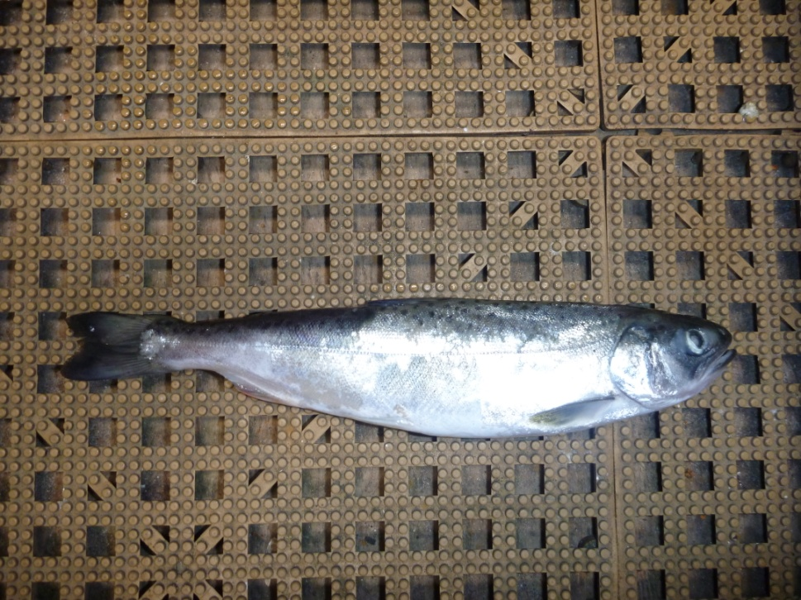

Sincerely,
Bonneville Project Fisheries

